Screenshots
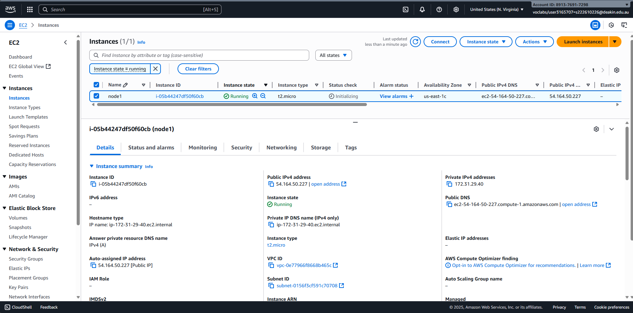
Picture 1 – Launched an instance, “node1”, from previous week AMI.
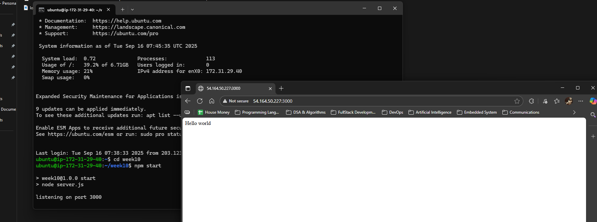
Picture 2 – Accessed to the webpage through “node1” ip4_address:3000.
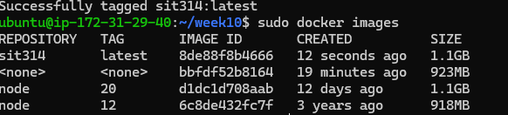
Picture 3 – Created a new Docker Image (node 20) instead of node-12 version.
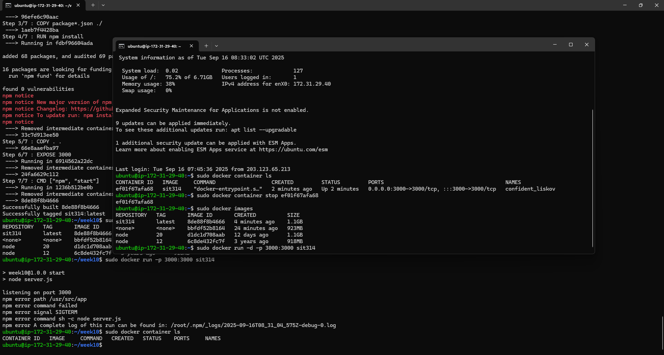
Picture 4 – Stop the running docker in a new terminal (connected to the same EC2).
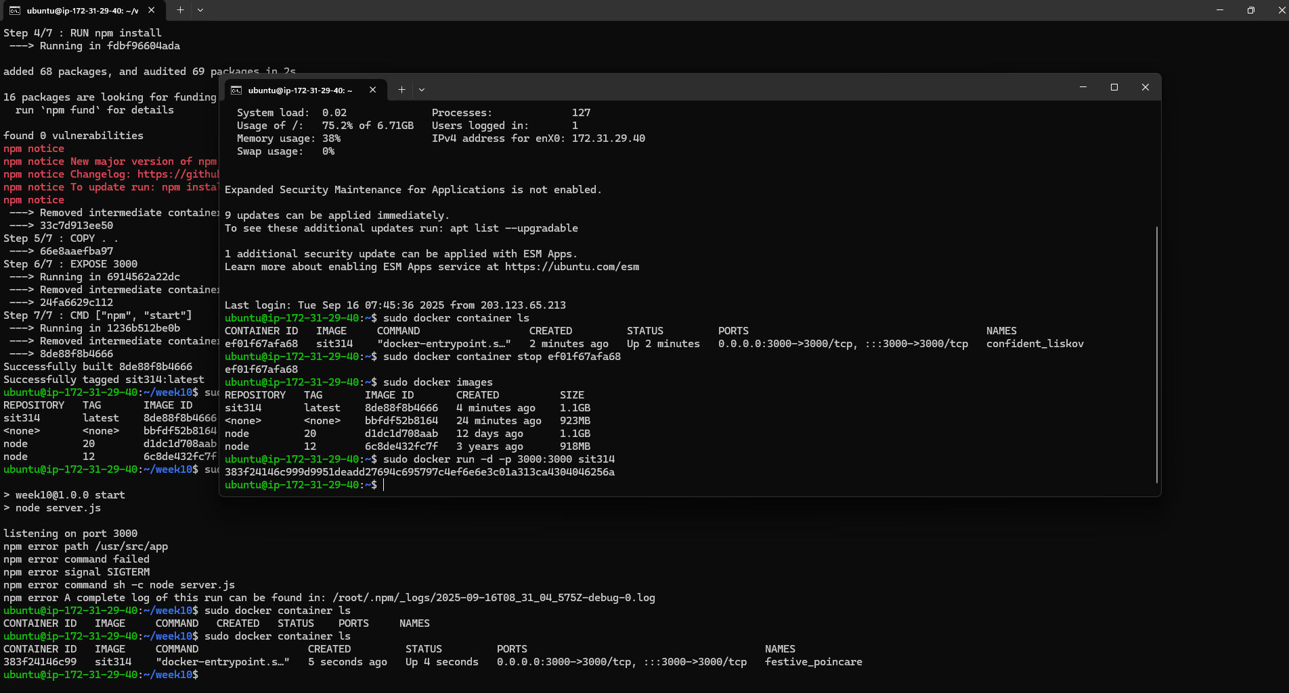
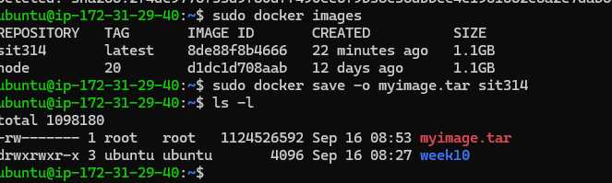
Picture 6 – Made a copy from docker image sit314.
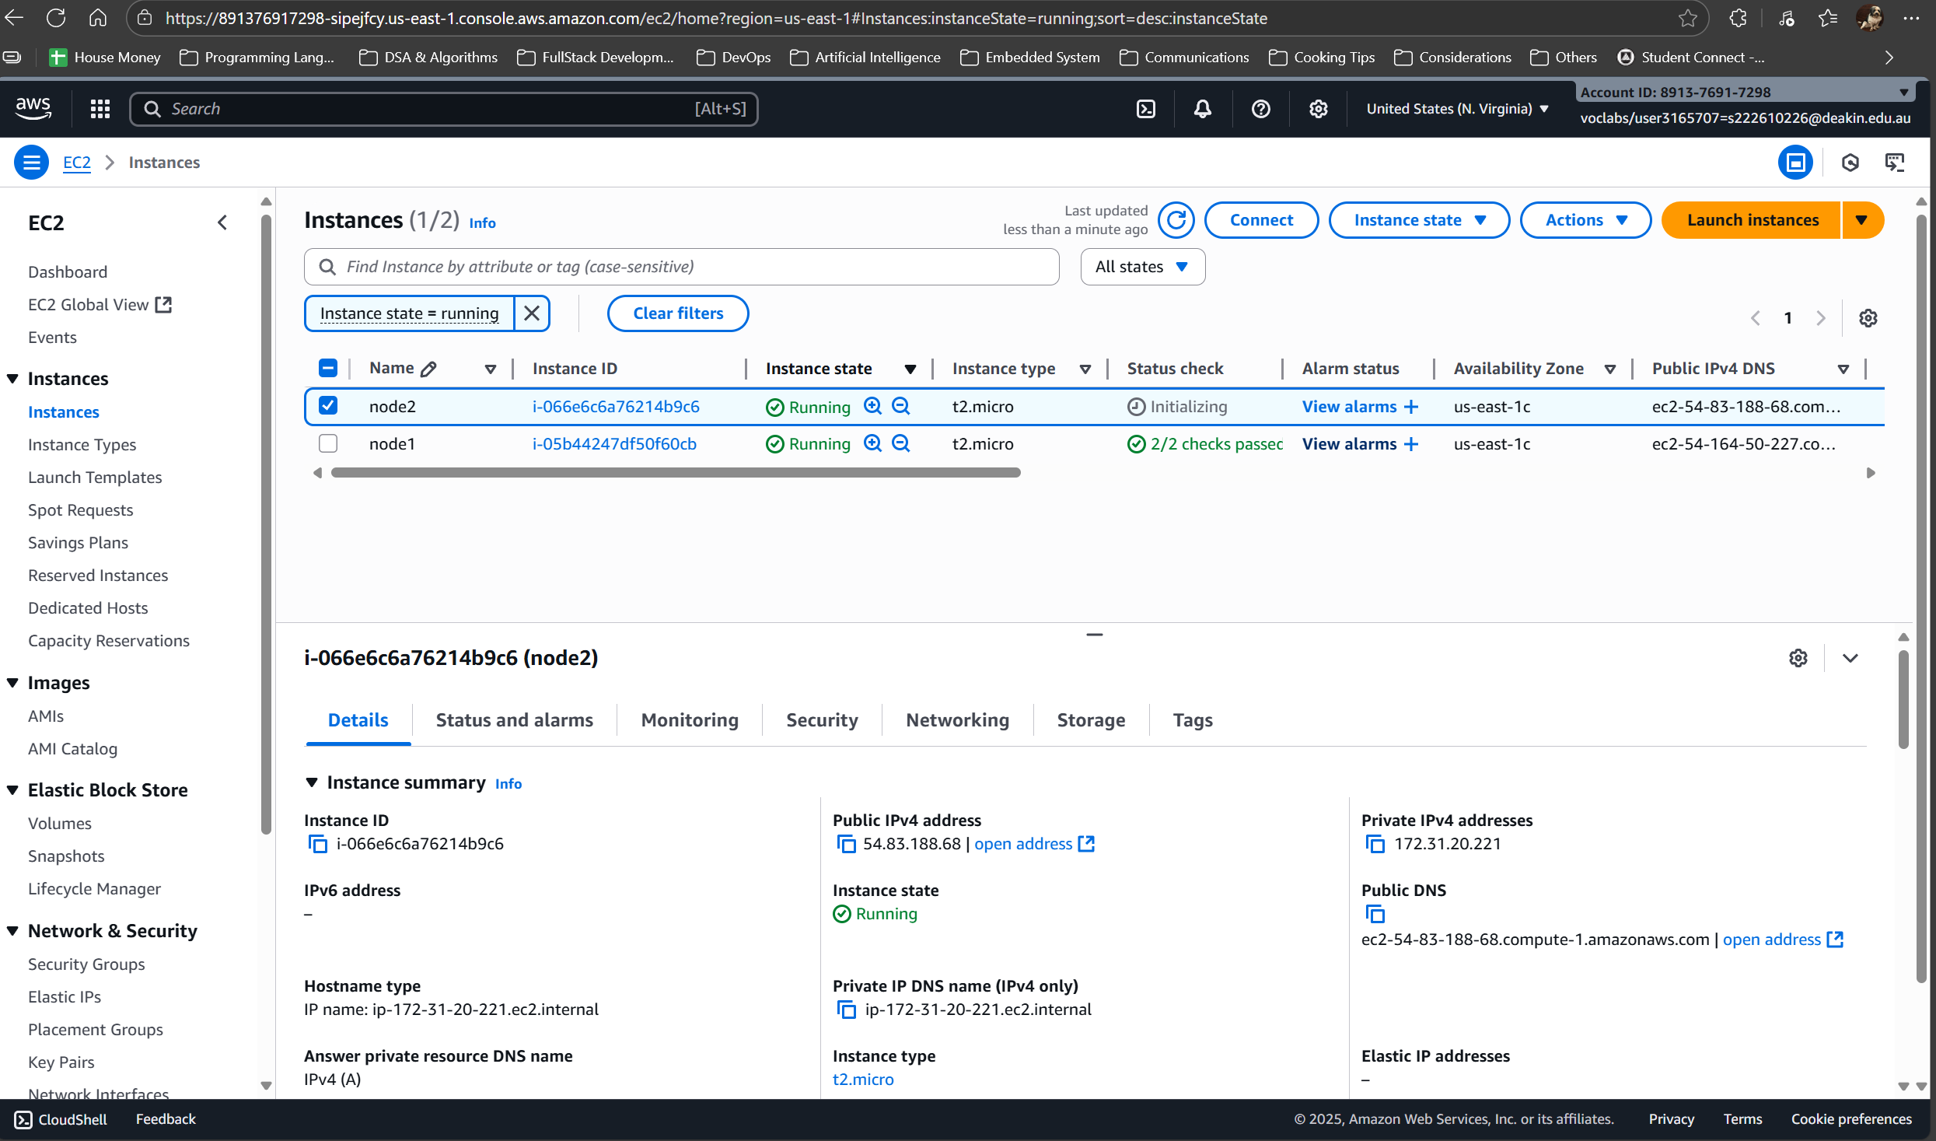
Picture 7 – Generated a second instance, “node2”, from the same AMI as “node1”.
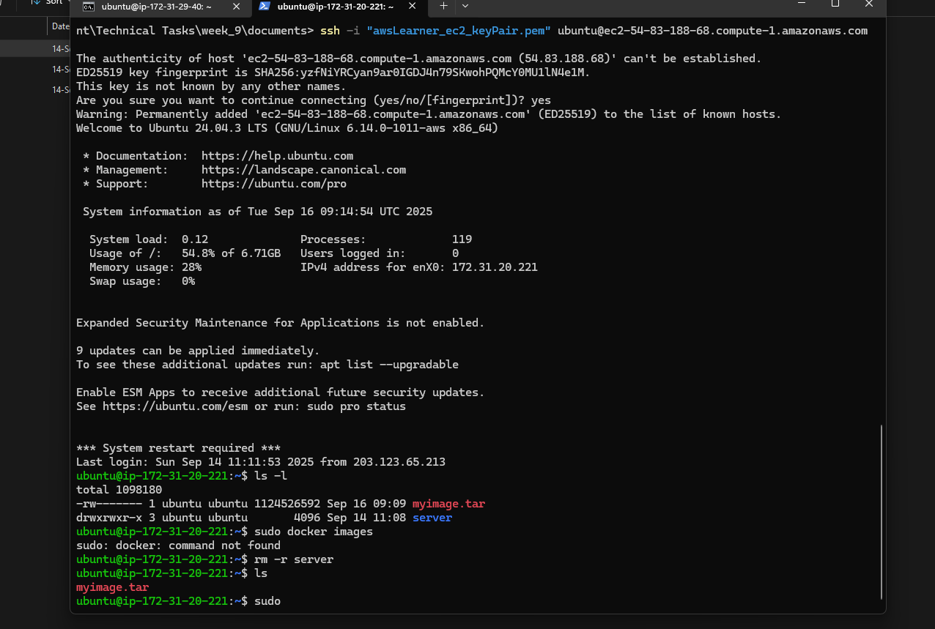
Picture 8 – Successfully transferred docker image from EC2 “node1” to “node2”.
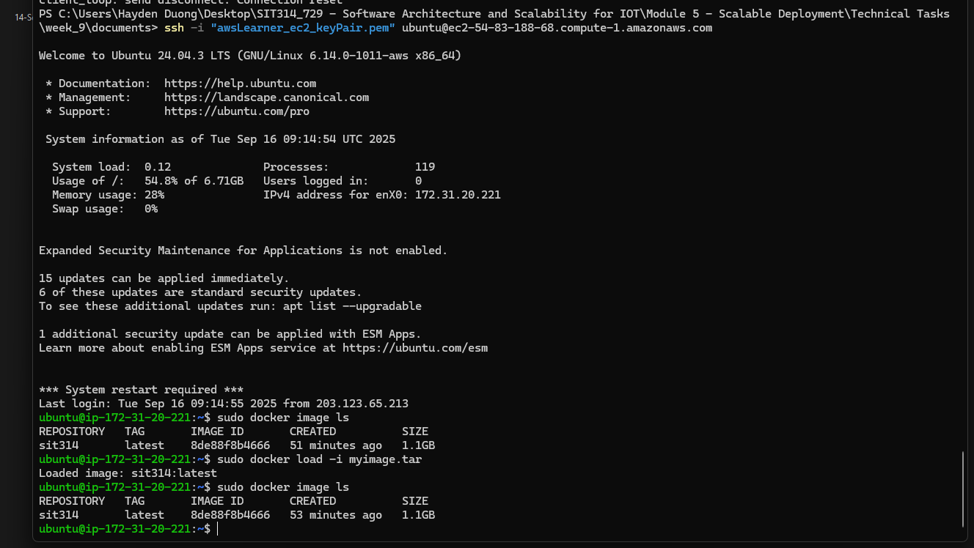
Picture 9 – The transferred image is loaded onto “node2”.
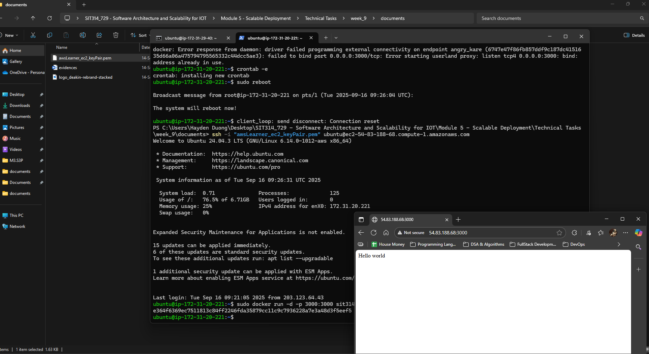
Picture 10 – Successfully accessed to the “node2” ip_adress:3000.

